Experiment Date: 14/01/2019

Date Submitted: 20/01/2019

experiment 11: Liquid Mixing (Short Report)

Bethany Mulliner – Group A4

**Contents**

|  |  |
| --- | --- |
| Topic | Page Number |
| Title Page | 1 |
| Contents Page | 2 |
| Results | 3 |
| Discussion of Results | 6 |
| Appendix I: Example Calculations | 7 |
| References | 7 |

**Results**

Impeller 1 (19cm x 6.6cm x 1.03mm)

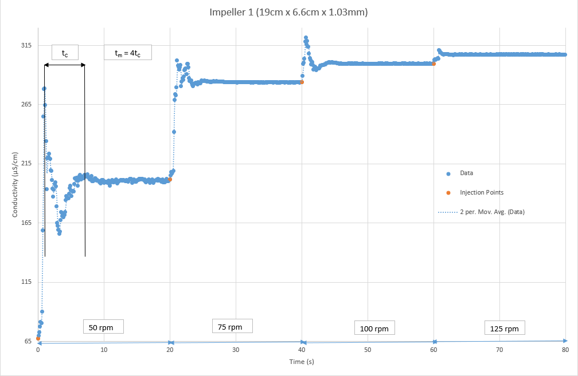

Di3 = 6859

|  |  |  |  |  |
| --- | --- | --- | --- | --- |
| **RPM (Ni)** | **Circulation Time (s)** | **Mixing Time (s)** | **NiDi3** | **1/ NiDi3** |
| 50 | 6.5 | 26 | 342950 | 2.91588E-06 |
| 75 | 3.7 | 14.8 | 514425 | 1.94E92E-06 |
| 100 | 3.9 | 15.6 | 685900 | 1.45794E-06 |
| 125 | 0.9 | 3.6 | 857375 | 1.16635E-06 |

Impeller 2 (21.7cm x 2.3cm x 1.08mm)

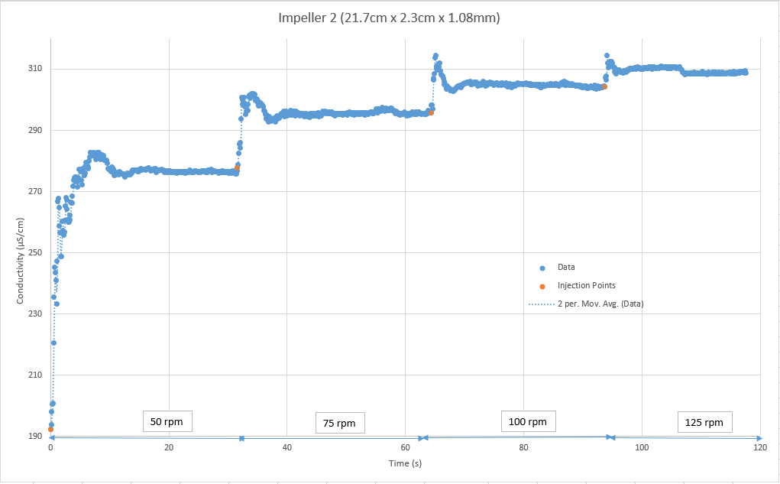

Di3 = 10218.31

|  |  |  |  |  |
| --- | --- | --- | --- | --- |
| **RPM (Ni)** | **Circulation Time (s)** | **Mixing Time (s)** | **NiDi3** | **1/ NiDi3** |
| 50 | 8.3 | 33.2 | 510915.7 | 1.95727E-06 |
| 75 | 6.5 | 26 | 766373.5 | 1.30485E-06 |
| 100 | 5.8 | 23.2 | 1021831 | 9.78635E-07 |
| 125 | 4.7 | 18.8 | 1277289 | 7.82908E-07 |

Impeller 3 (18.8cm x 2cm x 1.07mm)

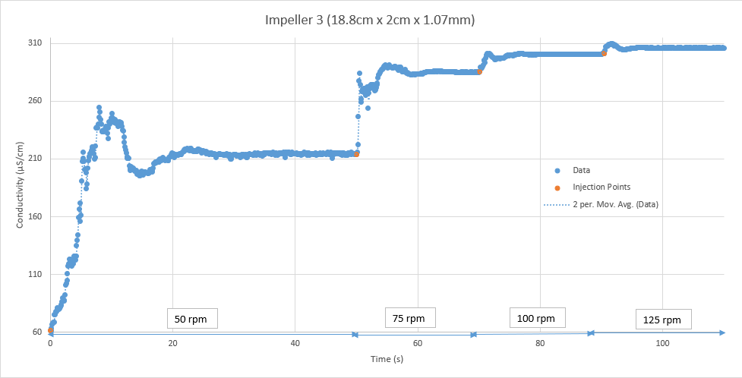

Di3 = 6644.672

|  |  |  |  |  |
| --- | --- | --- | --- | --- |
| **RPM (Ni)** | **Circulation Time (s)** | **Mixing Time (s)** | **NiDi3** | **1/ NiDi3** |
| 50 | 14.4 | 57.6 | 332233.6 | 3.01E-06 |
| 75 | 8.2 | 32.8 | 498350.4 | 2.01E-06 |
| 100 | 5.1 | 20.4 | 664467.2 | 1.5E-06 |
| 125 | 4.5 | 18 | 830584 | 1.2E-06 |

**Discussion of Results**

The aim of this experiment was to study the effects of different impeller and tank configuration, running at different speeds, on the rate of mixing of a NaCl solution in a stirred tank. This was done by recording the dispersion of the NaCl electrolyte tracer in water using a conductivity meter. [1]

The time it takes for the tracer concentration to settle down to a constant value can be used as a measure of the mixing time, tm, as at this point the solution can be considered to be fully mixed. In our results, the conductivity and hence the tracer concentration can be seen to fluctuate dramatically before settling to a constant value. As it can be rather difficult to estimate the point at which the solution can be considered to be within an acceptable range of its final value, a more straightforward way to calculate the mixing time is by using the circulation time, tc. On the first graph of results collected for impeller 1, the method of calculating tc, and tm from tc is illustrated. The circulation time is measured as the time between oscillations, measured between the first and second peaks in the graph after the tracer has been added. Four oscillations are considered to be the time taken for full mixing to take place, hence:

$$t_{m}=4t_{c}$$

The mixing time, tc, is dependent on the pumping capacity, φp, of the stirring, which in turn can be expected to be proportional to the tip speed of the stirrer, NiDi. When a tank is scaled up, the height, Hi, and the width, Wi, of the impeller blade are often scaled up proportionally to the impeller diameter, Di. Hence: [1]

$$t_{m}=4t_{c}$$

$$∴t_{m}∝\frac{V}{N_{i}D_{i}^{3}}$$

As a result of this equation, a graph of tm against 1/NiDi3 for each impeller should show a positive linear relationship. Both impellers 1 and 3 display these positive linear relationships, with R2 values over 0.78 for both, indicating a moderate-to-strong positive linear correlation. However, impeller 2 shows only a weak positive linear correlation with an R2 value of ~0.5. Due to this impeller being of a similar size to impeller 3, and due to impellers 1 and 3 showing similar results despite their difference in size, this is unlikely to solely be due to the dimensions of impeller 2. As can be seen by the initial value for conductivity for impeller 2, it is a lot higher than the other two impellers. This is due to the data collection at 50 rpm of impeller 2 being repeated due to operational error in carrying this out the first time around. However, the tank was not emptied and refilled between repeating this experiment, causing the baseline conductivity value of the tank to remain at the value achieved following the first attempt of the experiment, potentially causing the data collected for impeller 2 to be affected and hence erroneous.

Another issue that was found in performing the experiments was that it was impossible to be consistent in the location and speed of injection of the tracer, despite best efforts. This potentially caused some experiments to mix at different rates than would be expected than if the tracer had been injected uniformly over all the experiments.

A third issue was the collected conductivity data was quite difficult to process for the higher rpm values for each impeller, as at this point the tank had become quite saturated with the solution, leading to changes of conductivity to become much smaller and hence more difficult to see in the collected data. The speed at which these changes occurred at higher rpm values also made it more difficult to identify the exact location of the conductivity peaks. This could have caused some tc and hence tm values to be miscalculated, leading to the linear relationship not being as strong as expected.

From the collected results showing strong positive linear correlations, longer, thinner impellers were shown to produce results with stronger linear relationships than impellers that were shorter and wider. This is potentially due to the impeller diameter to tank diameter ratio being closer to the value of 1/3, where mixing will occur most efficiently for a hub mounted flat blade impeller turbine. [2]

**Appendix I: Example Calculations**

Di3

Mixing Time

NiDi3

1/NiDi3

**References**

|  |  |
| --- | --- |
| [1] | Heriot-Watt University School of Engineering & Physical Sciences, Fluid mixing times, Edinburgh: Heriot-Watt University, 2019. |
| [2] | R. Sinnott and G. Towler, “10.11.2. Liquid Mixing,” in *Chemical Engineering Design*, Oxford, Elsevier, 2017, pp. 647-653. |